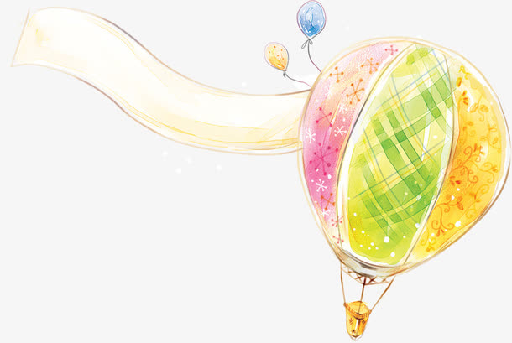
學生諮商中心107學年第1學期
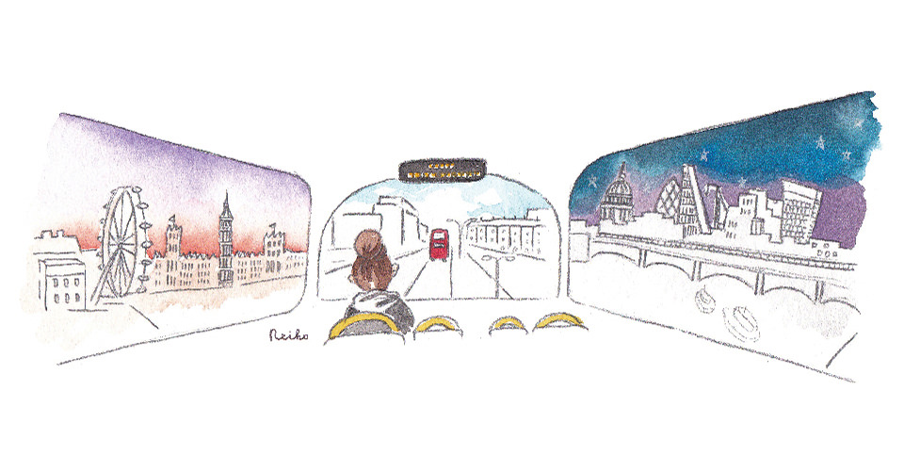
享受吧！一個人的異鄉旅行：國際生自我探索團體
姓名 |  | 國籍
性別 |  | 系級
電話 |  | 學號
e-mail
您是否曾有過參加團體的經驗？ | - 是。曾經參加的團體名稱或類型：___________________  - 否
是否可全程參加本活動？ | □是 □否
請填寫何以會想參加此團體？  對團體有何期待？  希望獲得哪些收穫？ | （請盡可能填寫）
報名方式 | - 表格填寫完畢後，請寄至peisyuan@thu.edu.tw（吳佩璇老師）。  我們會在收到報名表後一週內以電話或e-mail與您聯繫確認。  - 報名一週以上未接獲通知者，請來電確認。（04）2359-0231轉23909

The Journey of Exploring Yourself in the Foreign Country:
Self-Exploration Group for THU’s International Students
Application Form
Name |  | Nationality
Gender |  | Major
Cell Phone |  | Student ID
E-mail Address
1. Have you ever participated in any kind of group counseling before?
□Yes, the topics of the group counseling were: _____________________________
___________________________________________________________________
□No.
2. Would you fully participate in our group activities?
□Yes. □No.
3. Please write down the reasons why you want to participate in this group? What are your expectations from this group? What do you want to learn from this group experience? (the more you write, the more we understand!)

Application | - Please email to peisyuan@thu.edu.tw after filling the application form (Ms. Pei-Syuan Wu, 吳佩璇). We will contact you with phone or email after receiving your application.  - Please contact us if you have not received any response in a week after applying. (04)2359-0231#23909

